Q1: Processes and Process States
Problem context: Online Examination Server | 6 Marks | Bloom’s Level K5 – Evaluate

1. Process-State Diagram
A process moves through five states during its life. In the exam server, each student session is one such process.
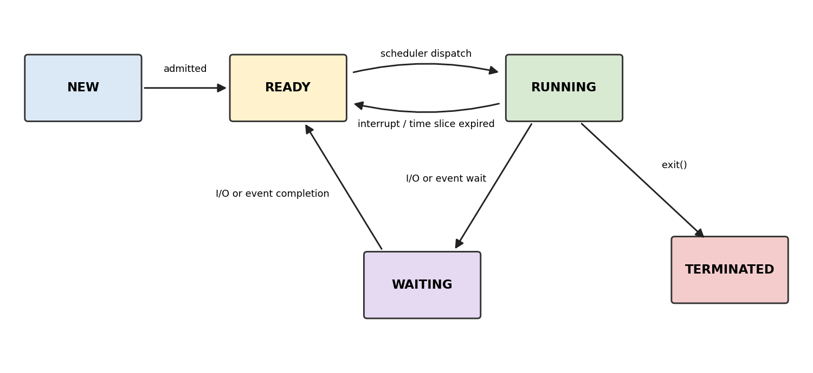
Transition | Exam-server example
New → Ready | fork() creates a session process; the kernel allocates the PCB and address space.
Ready → Running | The scheduler picks the session process for a CPU.
Running → Ready | Time quantum expires or a higher-priority process arrives.
Running → Waiting | The auto-save process blocks on a disk write, or a session blocks on read() from the client socket.
Waiting → Ready | The disk or network interrupt fires and the process becomes runnable again.
Running → Terminated | The student submits, exit() is called, and the parent reaps the process with wait().

2. Process Control Block (PCB)
The PCB is the kernel’s record of a process. In Linux it is struct task_struct. For each session process it holds:
- Identification: PID, PPID, user ID, group ID
- State: new / ready / running / waiting / terminated
- CPU context: program counter, stack pointer, general registers, flags (saved on every context switch)
- Scheduling info: priority, nice value, time slice remaining, queue pointers
- Memory management: page-table base register, memory limits, segments (code, data, heap, stack)
- I/O and file info: open file descriptor table (client socket, answer-log file), pending I/O requests
- Accounting: CPU time used, start time, parent/child links
- Signals: pending and blocked signal masks

3. Program: fork() Children Observed with ps and /proc
Compile with: gcc exam_fork.c -o exam_fork
// exam_fork.c
#include <stdio.h>
#include <stdlib.h>
#include <unistd.h>
#include <sys/wait.h>

#define N 5 // use 5 to observe; raise to 2000 to stress-test

int main(void) {
printf("Parent (server) PID = %d\n", getpid());

for (int i = 0; i < N; i++) {
pid_t pid = fork();
if (pid < 0) { perror("fork"); exit(1); }

if (pid == 0) { // child = one student session
printf("Session %d: PID=%d PPID=%d\n", i, getpid(), getppid());
sleep(60); // simulate waiting (I/O-bound)
exit(0);
}
}

for (int i = 0; i < N; i++) // parent reaps children
wait(NULL);

printf("All sessions terminated.\n");
return 0;
}

Observing the processes (second terminal)
./exam_fork &
ps -o pid,ppid,stat,wchan:20,rss,vsz,cmd --ppid $(pgrep -o exam_fork)
cat /proc/<child_pid>/status | egrep 'Name|State|Pid|PPid|VmRSS|voluntary'
ls /proc/<child_pid>/fd # open file descriptors (PCB I/O info)
cat /proc/<child_pid>/stat # raw PCB-like fields

Expected observations: sleeping children show state S (Waiting); a running one shows R (Running or Ready); after exit() but before the parent calls wait(), a child shows Z (zombie, i.e. Terminated). The values voluntary_ctxt_switches and nonvoluntary_ctxt_switches in /proc/<pid>/status show how often a process blocked by itself versus was preempted.
Evidence: paste your own screenshots of the ps and /proc output here. The sample below is illustrative only.
PID PPID STAT WCHAN RSS VSZ CMD
4121 4120 S hrtimer_ 580 2360 ./exam_fork
4122 4120 S hrtimer_ 576 2360 ./exam_fork

4. Evaluation: Where the Time Goes with 2,000 Processes
Cost | Analysis
Context switching | Each process switch saves and restores registers and switches page tables, which flushes the TLB and pollutes caches. The direct cost is a few microseconds, and the indirect cache-miss cost is much larger. With 2,000 processes on, say, 8 cores, each process gets a thin slice and switch overhead takes a large share of CPU time.
Memory per process | Each process needs its own PCB, kernel stack (about 16 KB), page tables, and heap and runtime (a Python or Java session can easily be 20–100 MB). At 2,000 × 50 MB ≈ 100 GB, the server starts swapping. Swapping is the most likely cause of sessions “hanging”.
I/O waiting | Sessions spend most of their life blocked on sockets and auto-save disk writes. Blocked processes use no CPU but still hold memory. Many simultaneous auto-saves queue at the disk, and bandwidth-heavy proctoring video competes for the same I/O.
Other limits | Process table limit (ulimit -u, pid_max), file descriptors, and a long run queue (check with uptime and vmstat 1).

Judgment: One process per student is not a sound design at this scale. It gives excellent isolation, but 2,000 mostly idle sessions pay the full process cost for almost no CPU work. The hang is explained by memory pressure plus scheduling overhead, not by the CPU being truly busy.

5. Design Decision
Option | Isolation | Memory | Switch cost | Scalability
Process per student | Excellent | Very high | High | Poor
Thread per student | Weak (shared address space) | Low | Low | Good, up to a few thousand threads
Fixed pool of worker processes | Good (per worker) | Bounded | Low (count ≈ core count) | Best

Decision: a fixed pool of worker processes (about one per core), each multiplexing many sessions with a thread pool or an event loop (epoll). The proctoring-video workload is separated into its own pool.
Defense:
- Memory is bounded and predictable, whether 200 or 2,000 students log in.
- Context switches stay limited, since runnable workers ≈ cores.
- A crash affects only the sessions on one worker (about 1/N of students), not the whole server, and a supervisor can restart that worker.
- Auto-save and video get separate pools, so a video overload cannot starve answer saving, which is the critical function in an exam.
- Sessions are mostly waiting on I/O, so a small number of workers can serve many of them well.

6. Alternative Concept: Thread per Session
Solution: One server process creates a thread per student with pthread_create(). All threads share the code, heap, and file table. Each thread has its own stack, registers, and thread control block.
- Context-switch time: A thread switch within the same process does not change page tables, so there is no TLB flush. This is typically about 1–2 µs, roughly 2–5× cheaper than a process switch (the exact ratio depends on hardware).
- Memory per session: A thread needs only a stack plus a small control block, and only touched stack pages are committed. This is typically tens of KB, against tens of MB for a full address space. 2,000 sessions ≈ tens to hundreds of MB in total, instead of about 100 GB.
- Effect of a crash: This is the weakness. A segfault or unhandled fault in one thread kills the whole process and all 2,000 sessions. A bug or data race in one session can also corrupt shared memory, and shared data needs locks.
Conclusion: Threads win on speed and memory but lose on fault isolation. The pooled-workers design in Section 5 combines both: threads inside workers for efficiency, multiple processes for containment.

7. Evidence Checklist
- State diagram (Section 1) and PCB description (Section 2)
- exam_fork.c source plus screenshots of ps and /proc output (Section 3)
- Optional: run with N=2000 and capture vmstat 1 and free -m to show memory and switch pressure
- Defended design decision (Section 5)

